**Sample report:**



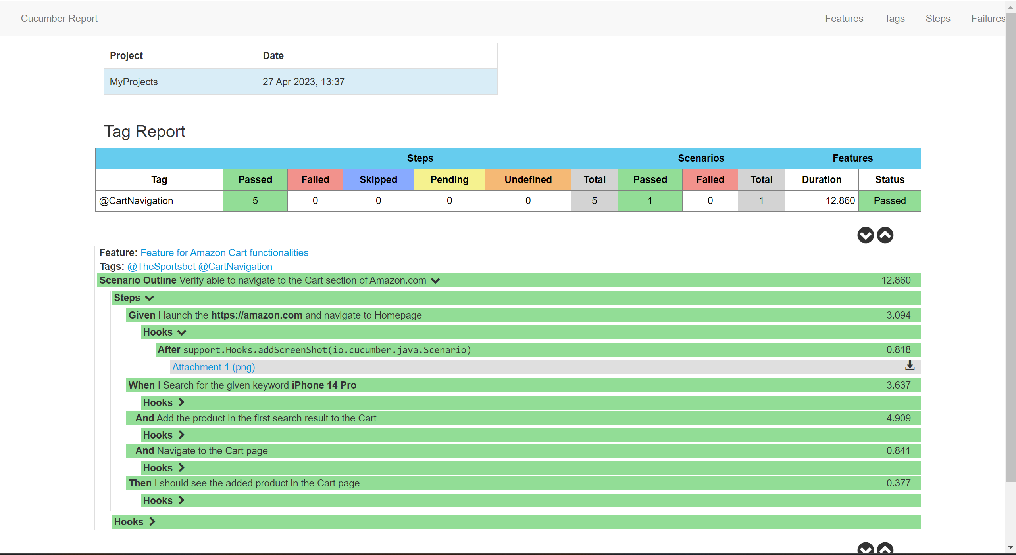

Screenshot attached:

